**Open Loop**

**Analog Filter Wizard**

Specification

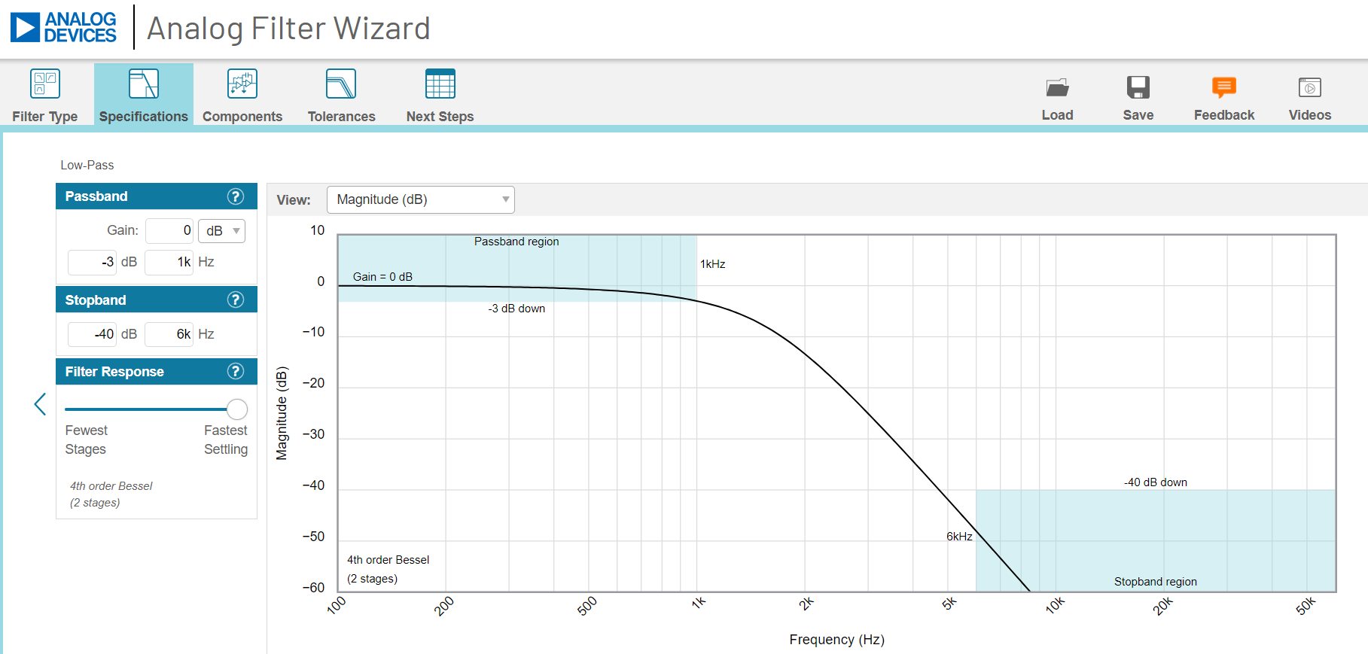

Component

Note. Leave A-stage alone and increase capacitor size in B-stage.

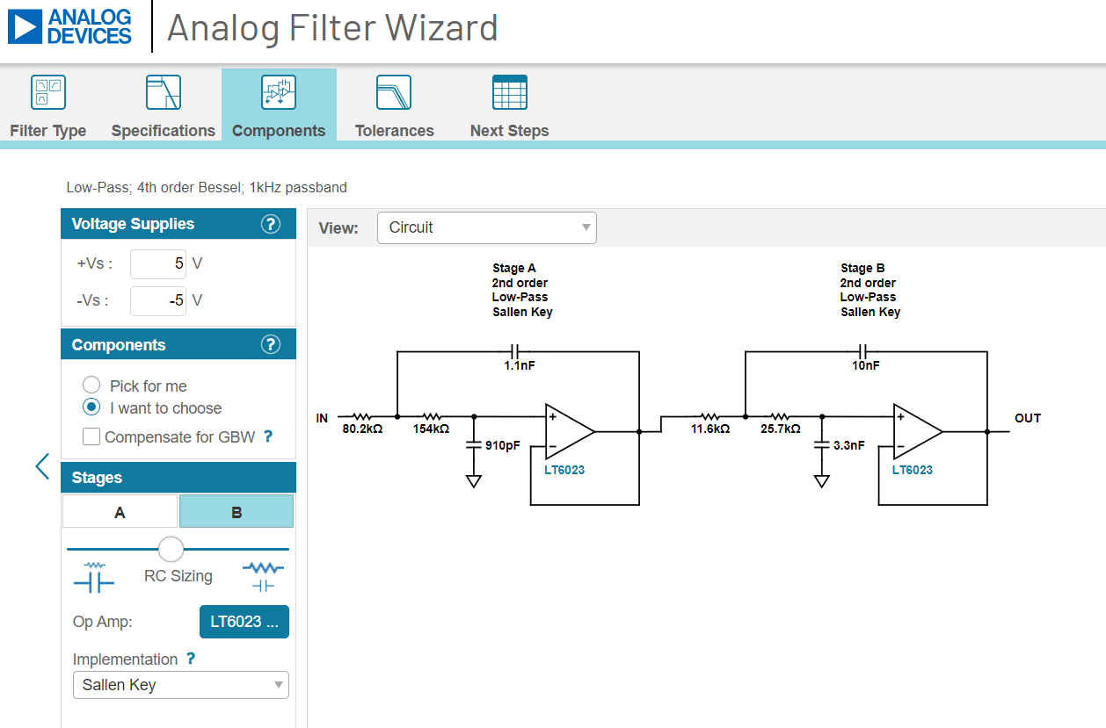

Tolerances

Note. When you specify lower E-series values, the pole locations can significantly affected. Ask me how I know ☹

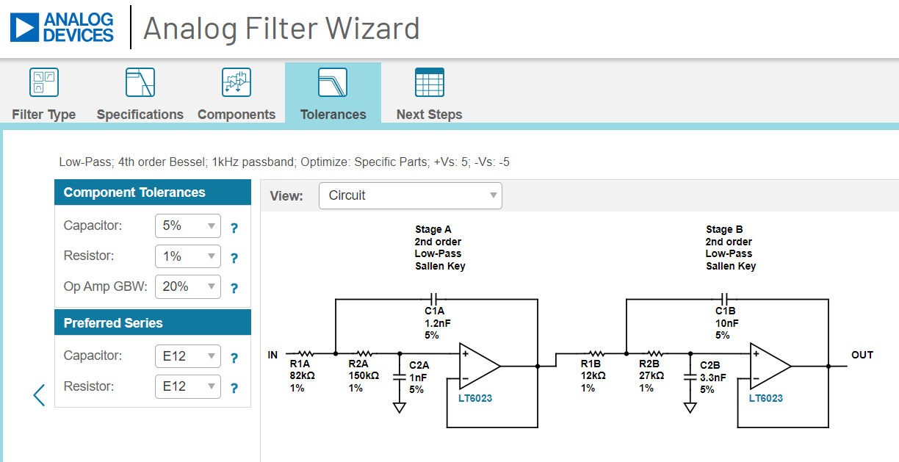

**ModelSim**

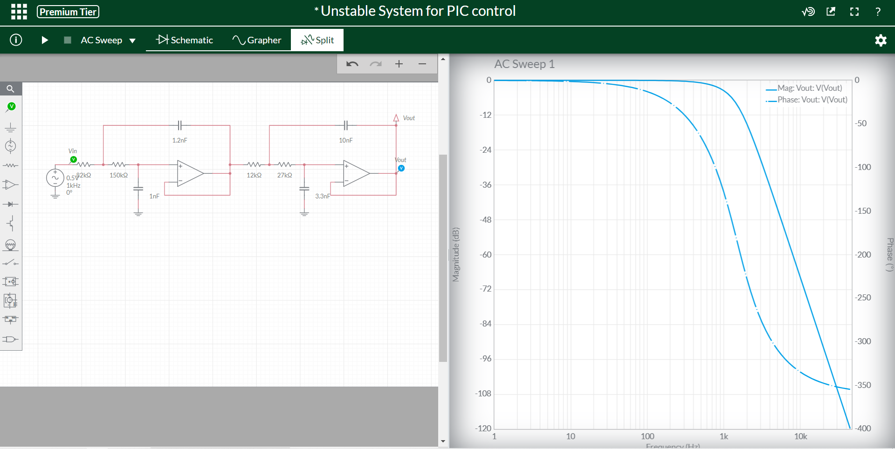

Verified that the magnitude is down -3dB at 1kHz.

**Excel**

Calculate Transfer Function for each opamp

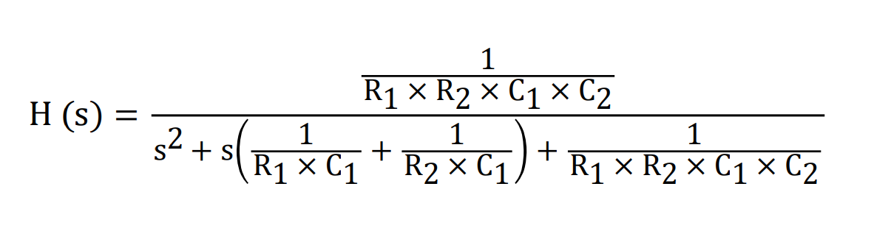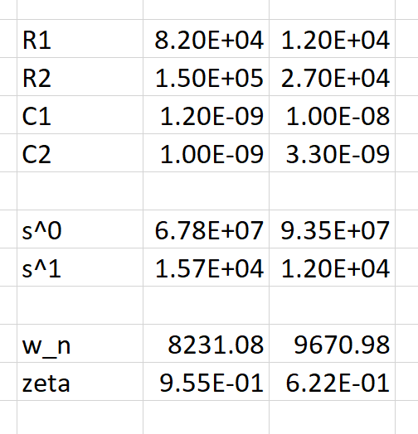

**Matlab**

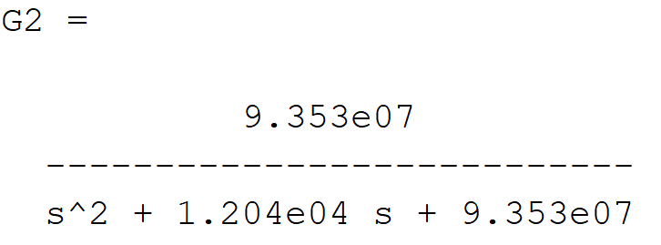

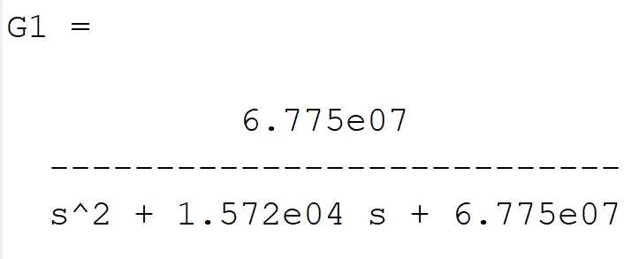

G1*G2

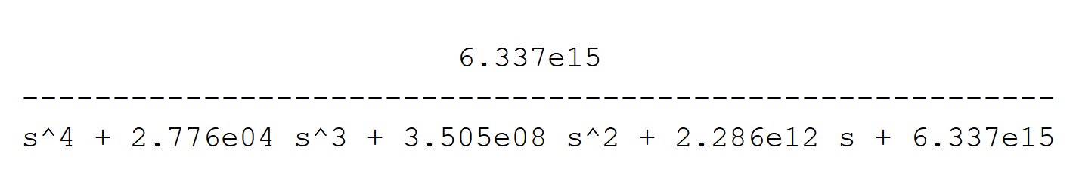

pzmap(G1*G2)

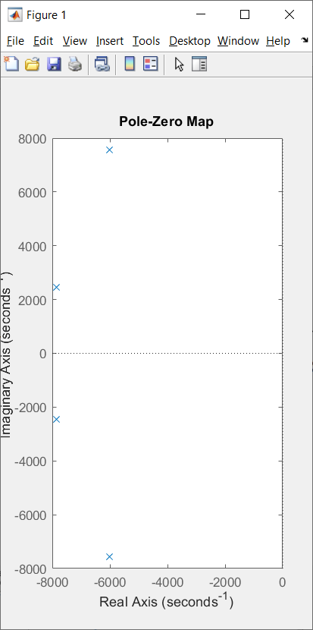

With these pole location, predict the closed loops step reponse.

margin(G1*G2)

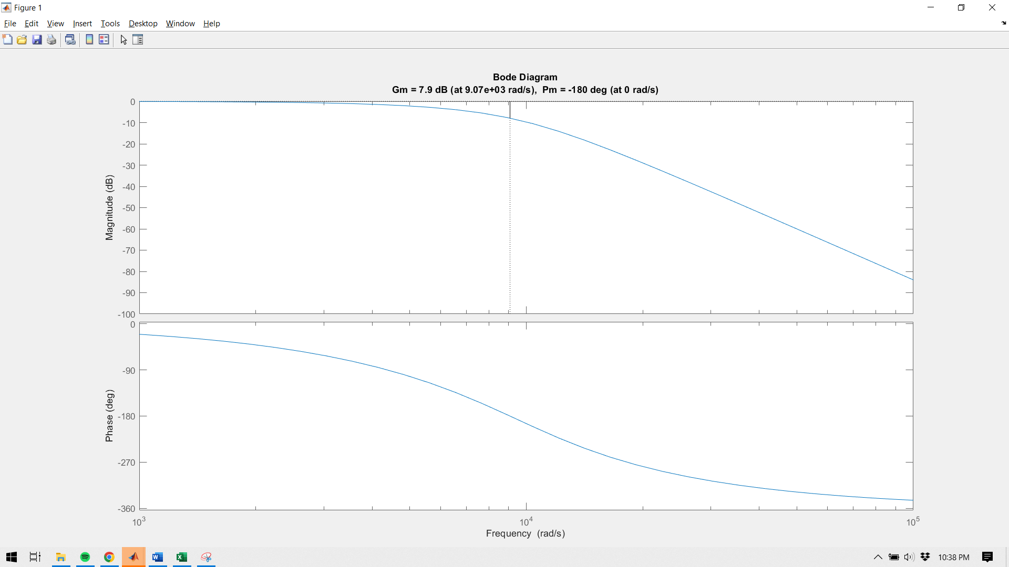

Note that the gain margin is 7.9

With a gain margin, we can scale G1*G2 by 10^(7.9/20) = 2.5 before the closed loop goes unstable. This is consistent with the Nyquist diagram below.

nyquist(G1*G2)

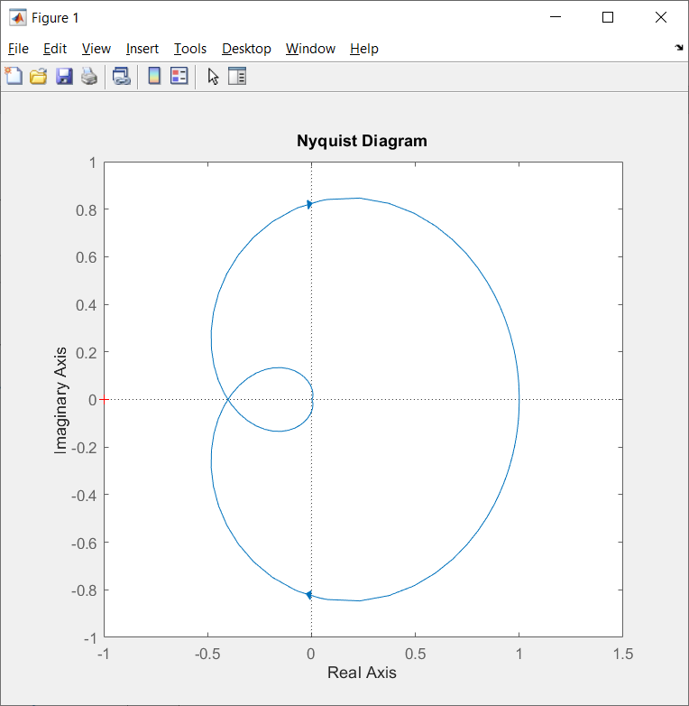

rlocus(G1*G2)

Root Locus shows that the poles will move into the RHP when the gain is 2.58. This is very close to the value of 2.5 determined by the phase margin above.

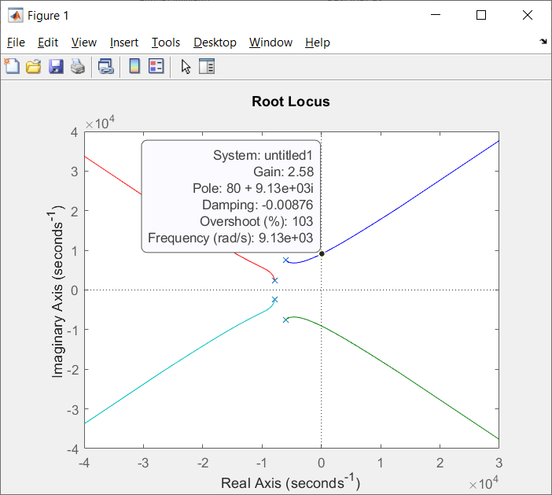

**Closed loop**

**ModelSim**

Gain = 1

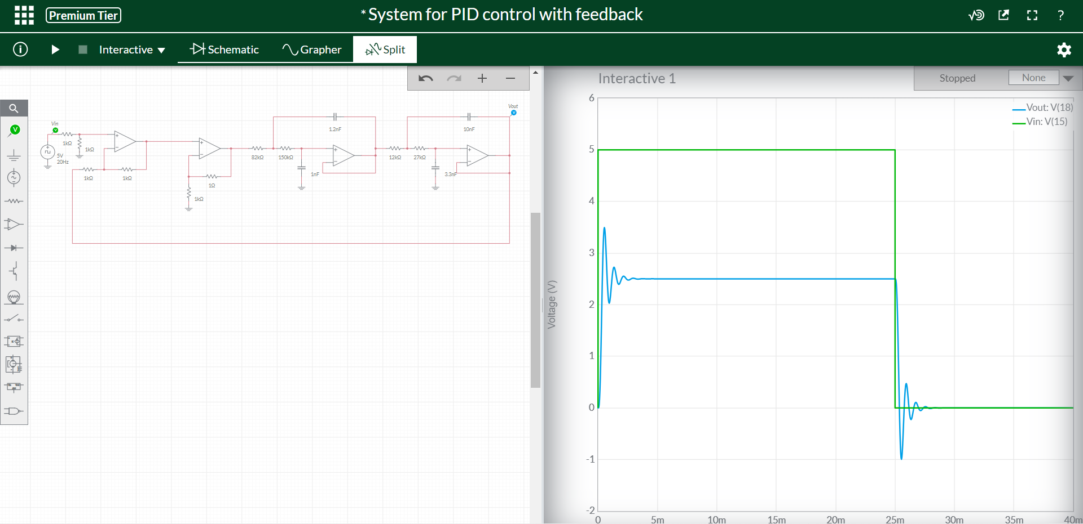

Notice steady state error. The output is 2.5, half the command input of 5.0

Gain = 2.5

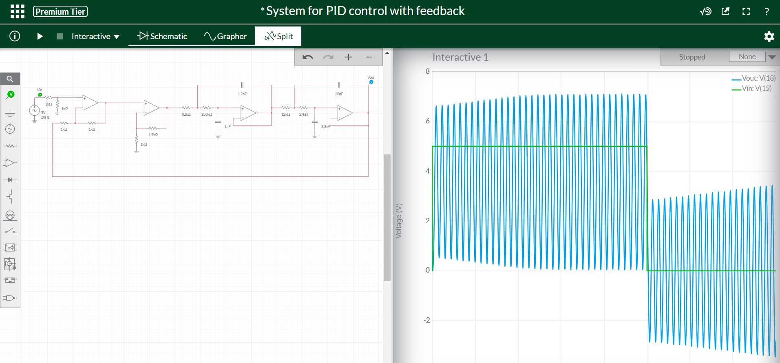

Yup, the system is unstable and unable to be controlled.

Closed loop transfer function.

step(feedback(G1*G2,1))

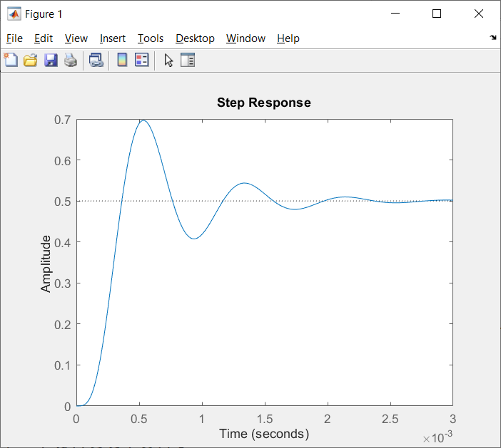

Note that the input is a unit step with amplitude 1. The output is a oscillating step response with final value aroung 0.5. Thus the steady state error is around 0.5. We can compute this using the closed loop transfer function, determined from Matlab as:

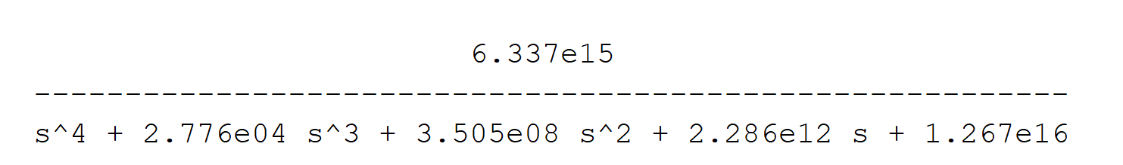

Steady state error = Y/R*1/s*s at s=0

This works out to 0.63/1.27 = 0.5 so the same as Matlab.